2024 Moosewatch for Educators
at Isle Royale National Park, Michigan

Workshop will meet June 24-July 1, 2024

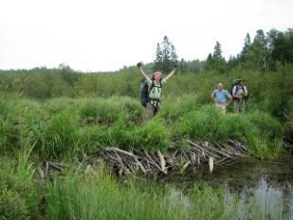
Workshop Description:
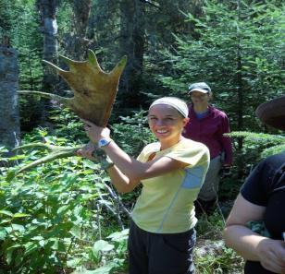
Moosewatch for Educators is a unique field experience in support of the ecological study of wolves and moose at Isle Royale National Park. Educators will receive the technical instruction needed to participate as a member of a backcountry research team. Although not as strenuous as “regular” Moosewatch Expeditions, participants will be operating in an off-trail wilderness setting involving travel by canoe and foot. You will learn field research methods, backcountry navigation, and backpacking/wilderness living skills. The workshop
will integrate aspects of earth science, botany, general ecology, and the use of literature in teaching science. Participants will discuss development of lesson/unit plans for use at their local schools.

Goal and Objectives:
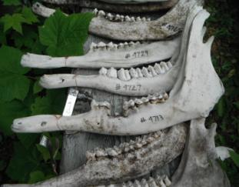
The general educational goal of this workshop is to enhance problem-solving and project-based learning skills of teachers and other educators by providing standards-based instruction within a real- world research setting. This goal will be fulfilled with curriculum incorporating more specific learning objectives and applicable activities related to:
- Field research methods to generate measurable scientific data;
- Field navigation techniques using GPS and compass;
- Wilderness living and travel techniques in a remote, backcountry environment;
- Experiential learning instructional strategies for elementary and secondary students; and
- Next Generation Science Standards.

Schedule of Activities: Day 1: Meet at Fort Wilkins State Park in Copper Harbor, MI. Orientation, gear check, dinner. Day 2: Travel to Isle Royale aboard the Isle Royale Queen IV. Set up first base camp. Days 3-7: Participate in field research. Travel by canoe to a new base camp. Visit Bangsund Cabin (home of the Moose/Wolf research), the historic Edison Fishery and Rock Harbor lighthouse. Day 8: Return to Rock Harbor for lunch. Afternoon departure for the return to Copper Harbor. Throughout the week basic backcountry navigation, research methods and wilderness living skills will be incorporated in daily activities. Participants will also have opportunities to engage in reflective group discussions.
Cost: $1,200 resident/non-resident per participant – this covers 45 SCECH hours (continuing education approved by the State of Michigan for Michigan teachers), transportation from Copper Harbor to Isle Royale, water taxi and canoes. Participants need to provide basic backpacking equipment and food. For more details, contact Karen Bacula - kbacula@mtu.edu
Limited to 5 educators. Apply early!
APPLICATION FORM: Moosewatch For Educators at Isle Royale

Please type or print in ink clearly.

Name _____________________________________________________________ First M.I. Last

Home address ____________________________ Street City State ZIP

Date of birth

Preferred email _________________________________

Preferred phone _________________________________

School name______________________________________________________________

School address _______
Street City State ZIP

School District _____________________________________________________________

Current subject areas taught ____________________________________________________

Grades taught __________________________

I agree to all of the following in order to participate in a summer 2024 field session:
- Read and respond to all preparatory materials and communications prior to the workshop.
- Consent to the release of my name, address, and email address to other participants.
- Fully participate in each day of the field session.
- Meet the requirements of the syllabus for the workshop.
- Consent to the release of my photograph for publications.

Signature _____________________________________________Date __________
Return the completed application form & questionnaire (attached) by April 2, 2024 to: Karen Bacula
Director, Isle Royale Institute
Email: kbacula@mtu.edu
NOTE: Applicants will be notified of their acceptance to the workshop beginning April 24.
Upon acceptance to the workshop, participants will be provided a Moosewatch health form and session details. A $150 deposit is due by April 30 by check or money order made out to Michigan Technological University. Full payment is due at least one month before your session.
2024 Moosewatch for Educators
Application Questionnaire

Please enter your responses below after each question:

1. In a few sentences, please introduce yourself to us. Include information about your
education, interests, previous volunteer and travel experience, or whatever may be the
most relevant information about yourself.

2. Please tell us why you are choosing to participate in this workshop. What are your
expectations and what do you hope to gain and to contribute from this experience?

How do you think you will incorporate what you have learned into classroom teaching?

3. Although all of our work will be done on day hikes and we return each evening to basecamps that are in established camping areas, field work can be both physically and emotionally demanding. Please indicate below whether you have any concerns about your participation in the workshop. Some concerns that are common among participants are dealing with weather extremes (it can get cold and it will likely rain at some point); a lack of privacy (we all share one relatively small camping site and spend almost all of our time together); primitive facilities (we have access only to outhouses and no running water); a lack of showers (you will learn some tips and tricks to make this less of an issue); an ability to keep up with the group (we tend to move slowly in the backcountry off trail).

4. This trip is designed for participants of all experience levels who are able to hike on
uneven terrain for up to 7 hours on several days. We will also be moving between
campsites by canoe. To help us understand your experience level, please describe any
previous hiking, canoeing, car camping, and overnight backpacking trips you have completed. If this will be your first camping or wilderness experience, please let us know. This will not reduce your chances for acceptance into the workshop, but it is important in our planning and preparation for the field sessions. Feel free to add other information here to demonstrate that you are physically and mentally prepared for such a field workshop.

5. Please indicate any details of your medical history of which we should be aware (e.g., physical limitations, chronic conditions, psychological conditions, etc.).

