“Moosewatch” (The Wolves and Moose of Isle Royale)

Research Expedition Details – 2024

Expedition #1: May 11 - 19, access via Voyageur II, from Grand Portage, MN to Windigo,
returning to Grand Portage, MN from Windigo
Expedition #2: May 22 – 30, access via Voyageur II, from Grand Portage, MN to Windigo,
returning to Grand Portage, MN from Windigo

Expedition #3: June 3 - 11, access via Isle Royale Queen, from Copper Harbor, MI to Rock

Harbor, returning to Copper Harbor, MI, from Rock Harbor
Expedition #4: July 26 – Aug. 3, access via Ranger III, from Houghton, MI to Mott Island,
returning to Houghton, MI from Rock Harbor

Dear Research Expedition Volunteers:

Welcome to the Moosewatch research expedition! Since 1988, volunteers have provided essential physical and financial assistance to wolf-moose research each summer at Isle Royale. In the field, the basic objective of each hiking team is simple: during a week-long backpacking trip, to carefully search as much area as possible for moose bones. Records are also kept of certain mammals, birds, and plants of special interest, and there are opportunities to learn a lot of natural history about this secluded island. We will be backpacking across the island, mostly traveling off-trail, and wilderness-camping each night. This is NOT a routine backpacking trip; it will be constantly necessary to go over and under fallen trees, work your way through thick vegetation when you can’t see your feet, climb up and down rock ridges, and negotiate bogs and numerous wetlands, all the while keeping a sharp lookout for moose bones. Previous backpacking experience is a requirement. Remember, most of our travel is NOT on trails. It is absolutely essential that participants be in excellent physical condition, with boots and packs that are already very well “broken-in.” Unlike most backpackers, we often end a trip considerably heavier than when we started, because of all the moose bones collected.

It must be clearly understood that these are not trips to observe wolves. We actually go out of our way to avoid confronting the wolves, as our presence disrupts their activities. Isle Royale wolves face a daily struggle in summer to raise growing pups and to stay alive themselves. For these wolves, human contact is not needed or desired.

For seven days, we will be mostly working and camping apart from other people and any facilities, and we will have to deal with whatever Mother Nature dishes out. The weather at Isle Royale is variable, so prepare for extremes. When it rains, we usually keep walking, so sturdy raingear (NOT ponchos) is a must. We have timed the expeditions to avoid the heavy insect swarms of mid-summer, but expect to see some black flies and/or mosquitoes.

Of course, you will see Isle Royale in a way that very few people ever do, and hopefully you will come away with an understanding of how the “real world” and its non-human inhabitants function!

Sincerely,

Rolf O. Peterson, John A. Vucetich, and Sarah Hoy
Principal Investigators

For more information on the wolves and moose of Isle Royale, including accounts from past volunteers, please see www.isleroyalewolf.org.

I. ARRIVING AND DEPARTING

A. Expedition #1 (May 11 - 19) Starts and ends at Windigo

You should arrive at Grand Portage, MN in time to take the ferry boat that leaves for Rock Harbor on Isle Royale at 7:30 AM Central time on May 11, 2024. Plan to be at the dock at least 30 minutes prior to sailing. That ferry is called the Voyageur II. IT IS YOUR RESPONSIBILITY TO MAKE YOUR OWN RESERVATION ON THE VOYAGEUR II, to and from Windigo from Grand Portage. Seats are limited, so book early (ferry usually begins booking in January).
You can make reservations and learn more about the ferry service by calling 218-600-0765 or 218-475-0024 through April; or at their website: https://www.isleroyaleboats.com.
Because you’ll want to arrive at Grand Portage the night before the ferry, it’s useful to know about lodging there. There is one local option: Grand Portage Lodge, call 218-475-2401 or 800-543-1384, and another inexpensive motel, Outpost Motel, about 7 miles east of Grand Marais, MN. Also, there are several motels in Grand Marais, MN, about 30 miles from Grand Portage.
Grand Portage is located in northeastern Minnesota on State Highway 61 approximately 6 miles (10 km) south of the US-Canadian border. The nearest airports to Grand Portage are in Duluth, Minnesota, USA and Thunder Bay, Ontario, Canada. Happy Times bus company runs from Thunder Bay, Ontario, Canada to the Grand Portage Lodge, Grand Portage, MN, USA, but it may not be accepting regular passengers, just lodge employees – check with them well in advance. There really isn’t any public transportation, but it should be easy to carpool with other volunteers, at least from Duluth. If you have not been to Grand Portage before, be aware that Grand Portage Lodge is two miles from the ferry dock and there is no easy way to get to the ferry dock without a car.
You will be sent the names of and contact information for your expedition team members about one month before the trip. We will also schedule a virtual meeting with confirmed volunteers well in advance of the expedition. This information may be useful for you to coordinate your travels with others on your expedition.
Your expedition will end when you board the Voyageur II at Windigo on May 19, 2024 (lunch is the last meal provided on that day). The ferry will take you back to Grand Portage, MN. You are responsible for booking this return trip. Arrival in Grand Portage, MN will be approximately 3:00 PM Central time. Occasionally weather disrupts departure, so be sure your return travel plans are flexible. Early departures cannot be accommodated.

Note: It is important to remember that you are responsible for making your own travel arrangements to and from Isle Royale. This includes ferry boat reservations and lodging before and after the expedition.

B. Expedition #2 (May 22 – 30) Starts and ends at Windigo

You should arrive at Grand Portage, MN in time to take the ferry boat that leaves for Windigo at Isle Royale at 7:30 AM Central time on May 22, 2024. Plan to be at the dock at least 30 minutes prior to sailing. That ferry is called the Voyageur II. IT IS YOUR RESPONSIBILITY TO MAKE YOUR OWN RESERVATION ON THE VOYAGEUR II, to and from Windigo from Grand Portage. Seats are limited, so book early (ferry usually begins booking in January).
You can make reservations and learn more about the ferry service by calling 218-600-0765 or 218-475-0024 through April; or at their website: https://www.isleroyaleboats.com. You will arrive at Windigo at about 9:30AM Central time (10:30AM Eastern time).
Because you’ll want to arrive at Grand Portage the night before the ferry, it’s useful to know about lodging there. There is one local option: Grand Portage Lodge, call 218-475-2401 or 800-543-1384, and another inexpensive motel, Outpost Motel, about 7 miles east of Grand Marais, MN. Also, there are several motels in Grand Marais, MN, about 30 miles from Grand Portage.
Grand Portage is located in northeastern Minnesota on State Highway 61 approximately 6 miles (10 km) south of the US-Canadian border. The nearest airports to Grand Portage are in Duluth, Minnesota, USA and Thunder Bay, Ontario, Canada. Happy Times bus company runs from Thunder Bay, Ontario, Canada to the Grand Portage Lodge, Grand Portage, MN, USA, but it may not be accepting regular passengers, just lodge employees – check with them well in advance. There really isn’t any public transportation, but it should be easy to carpool with other volunteers, at least from Duluth. If you have not been to Grand Portage before, be aware that Grand Portage Lodge is two miles from the ferry dock and there is no easy way to get to the ferry dock without a car.
You will be sent the names of and contact information for your expedition team members about one month before the trip. We will also schedule a virtual meeting with confirmed volunteers well in advance of the expedition. This information may be useful for you to coordinate your travels with others on your expedition.
Your expedition will end when you board the Voyageur II at Windigo on May 30, 2024 (lunch is the last meal provided on that day). The ferry will take you back to Grand Portage, MN. You are responsible for booking this return trip. Arrival in Grand Portage, MN will be approximately 3:00 PM Central time. Occasionally weather disrupts departure, so be sure your return travel plans are flexible. Early departures cannot be accommodated.

Note: It is important to remember that you are responsible for making your own travel arrangements to and from Isle Royale. This includes ferry boat reservation and lodging before and after the expedition.

C. Expedition #3 (June 3 – 11) Starts and ends at Rock Harbor

You should arrive at Copper Harbor, MI in time to take the Isle Royale Queen IV that leaves for Isle Royale at 8:00 AM Eastern time on June 3, 2024. Plan to be at the dock at least 30 minutes prior to sailing. IT IS YOUR RESPONSIBILITY TO MAKE YOUR OWN RESERVATION ON THE QUEEN. Seats are limited, so book early.
You can make reservations and learn more about the ferry service by calling 906-289-4437; by e-mail: isleroyalequeen@gmail.com; or at their website: www.isleroyale.com. When you arrive at the island, you will be greeted at the dock by the Petersons.
Copper Harbor is located about 50 miles north of Houghton-Hancock on the Keweenaw Peninsula (U.S. highway 41). There are several local motels and campgrounds. The closest airport is the Houghton County Memorial Airport (CMX). There is no public transportation from the airport, but there is a local limousine service (Copper Country Limo, phone 906-370-4761) and a taxi service (Superior Transportation Services, text or call 906-370-4094).
Because you’ll want to arrive at Copper Harbor, MI the night before the ferry, it’s useful to know about lodging in the local area. Visit the website for Copper Harbor, MI, to find a complete list of lodging options: http://copperharbor.org/places-to-stay/. A couple of the better-known motels are The Pines Resort (phone 906-289-4222) and Mariner North Resort (phone 906-289-4637).
You will be sent the names of and contact information for your expedition team members about one month before the trip. We will also schedule a virtual meeting with confirmed volunteers well in advance of the expedition. This information may be useful for you to coordinate your travels with others on your expedition.
Your expedition will end on June 11, 2024 when you board the Queen at Rock Harbor. The ferry will take you back to Copper Harbor, MI. You are responsible for booking this return trip. Arrival in Copper Harbor, MI will be approximately 6:00 PM Eastern time. Occasionally weather disrupts departure, so be sure your return travel plans are flexible. Early departures cannot be accommodated.

Note: It is important to remember that you are responsible for making your own travel arrangements to and from Isle Royale. This includes ferry boat reservation and lodging before and after the expedition.

D. Expedition #4 (July 26 – Aug. 3) Starts and ends at Mott Island

You should arrive at Houghton, MI in time to take the National Park Service ferry that leaves for Isle Royale at 9:00 AM Eastern time on July 26, 2024. Plan to be at the dock at least 30 minutes prior to sailing. That ferry is called the Ranger III. IT IS YOUR RESPONSIBILITY TO MAKE YOUR OWN RESERVATION ON THE RANGER III. Seats are limited, so book early with the NPS visitor center in Houghton.
You can make reservations and learn more about the ferry boat service by calling (906) 482-0984 or by visiting their website: https://www.nps.gov/isro/planyourvisit/ranger-iii-info.htm (you may have to copy and paste the link into your browser). When you check your luggage for the Ranger III, be sure the handlers know that you are getting off at Mott Island. When you arrive at Mott Island (the first stop at Isle Royale), you will be greeted at the dock by the Petersons.
Because you’ll want to arrive at Houghton, MI the night before the ferry, it’s useful to know about lodging in the local area. There are several options to consider:

Houghton Super 8 - (906) 482-2240
Country Inn & Suites Houghton - (906) 487-6700
Holiday Inn Express Houghton - (906) 482-1066 or (877) 863-4780

Quality Inn & Suites Houghton - (906) 482-1400 or (855) 213-0582

Copper Country Inn Houghton - (906) 482-5351

Hampton Inn Houghton - (906) 487-1700

Magnuson Hotel Copper Crown Hancock - (906) 482-6111

Ramada Waterfront Hancock - (906) 523-1037

The Vault Hotel Houghton - (906) 481-1100

Other options are at: https://www.keweenaw.info/where-would-you-like-to-stay/

Houghton is located in the north-central portion of Michigan’s Upper Peninsula, accessible by either federal highway US-41 or state highway M-26. It is the mainland headquarters of Isle Royale National Park and home of Michigan Technological University. (The Isle Royale visitor center is downtown on the Portage Canal.) The closest airport is the Houghton County Memorial Airport (CMX). There is no public transportation from the airport, but there is a local limousine service (Copper Country Limo, phone 906-370-4761) and a taxi service (Superior Transportation Services, text or call 906-370-4094).
You will be sent the names of and contact information for your expedition team members about one month before the trip. We will also schedule a virtual meeting with confirmed volunteers well in advance of the expedition. This information may be useful for you to coordinate your travels with others on your expedition.
Your expedition will end on August 3, 2024 when you board the Ranger III at Isle Royale. The ferry will take you back to Houghton, MI. You are responsible for booking this return trip. Arrival at Houghton, MI will be approximately 3:00 PM Eastern time. Occasionally weather disrupts departure, so be sure your return travel plans are flexible. Early departures cannot be accommodated.

Note: It is important to remember that you are responsible for making your own travel arrangements to and from Isle Royale. This includes ferry boat reservation and lodging before and after the expedition.

II. HOW TO PACK

Bring TWO bags:

- One bag must be a durable backpack suitable to carry everything needed in the field. It is also useful during day hikes to have a detachable fanny pack, or a small day pack (or “book bag”) that can be easily stowed in your backpack.

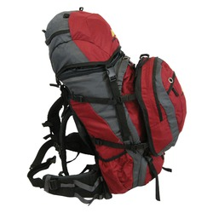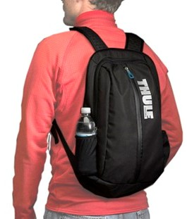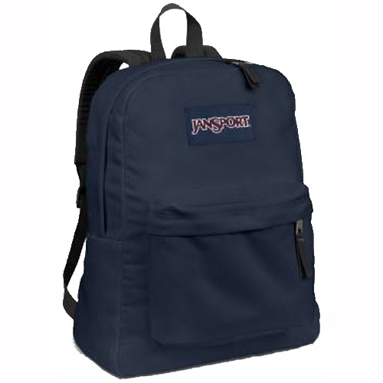
Backpack with detachable fanny or day pack Small day pack “Book bag”

- The other bag should be a duffel bag, athletic bag, or gear bag for clean clothes and items you will leave behind at base camp.
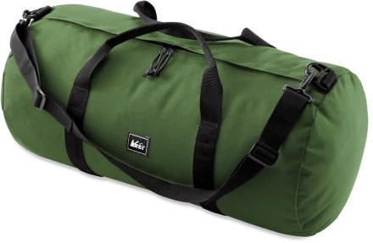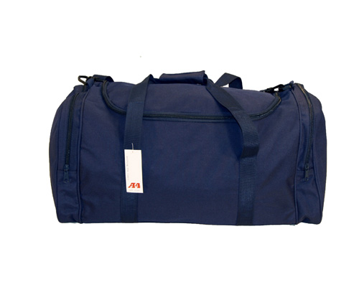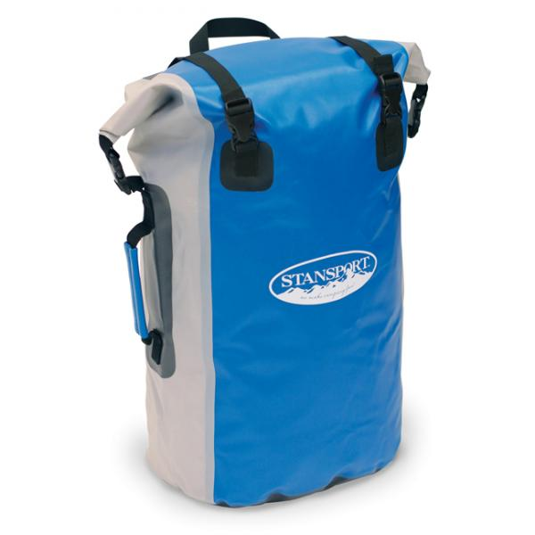
Duffel bag Athletic bag Waterproof gear bag

Do not bring more luggage than you can carry and handle on your own.

III. WHAT TO PACK

Please Note: we will supply pots and stoves for boiling water for meals, first-aid kits, GPS units, emergency communications, and water filters, plus all items needed to record data and collect bones. Each volunteer will provide their own food and meal utensils (see Section V below).

Weather considerations:

Your expedition will deal with whatever conditions Mother Nature brings on. The weather at Isle Royale is variable, so prepare for extremes. When it rains, we usually keep walking so sturdy rain gear (NOT a poncho, which will be quickly shredded by shrubs along the way) is a must. Typical temperatures in May are in the mid-50s F (12-14C) during the day and the mid-30s F (0-3C) at night. Average temperatures in June are slightly higher. In August, high temperatures are in the upper 60s and 70s F (19-25C) and typical lows are in the mid 50s F (12-14C).

Normal precipitation in May/June is around three inches (7.6 cm), usually in the form of rainfall, though snow is possible. Average August precipitation is slightly higher. Humidity can be very high or very low. Volunteers on all teams must be prepared to experience all types of weather – hot, cold, dry, snowy, wet, and windy. We have timed the expeditions to avoid the heavy insect swarms of mid-summer, but expect to see some black flies and mosquitoes.

Personal items to be supplied by volunteers:

  - Note: During your island sojourn all your food and equipment must be carried in a single backpack, so choose light weight items. For some day trips, you can use a small day pack or “book bag,” or better yet, simply empty out your backpack and use that for the day (your regular backpack provides more room for bones).

Bring clothing that can be layered to suit the conditions. Plan carefully so
you have what you need, but not more.

Detailed list of what to bring:

  - all medications you may require, including epi-pens if needed for bee stings
  - one backpack and one duffel or gear bag
  - small day pack or “book bag” that can be easily stowed on or in the backpack
  - sleeping bag adequate for possible freezing temperatures (Expedition #1 - 3)
  - sleeping pad
  - two 1-quart water bottles
  - headlamp (with batteries!)
  - tent, if you have one (we can provide one if you contact us ahead of time)
  - sturdy hiking boots that are “well-broken-in” before you arrive
  - sturdy hooded rain jacket and pants (NOT a poncho)
  - comfortable shoes for in camp (lightweight sandals or Crocs are fine,
try to avoid heavier running shoes, etc.)
  - socks (preferably wool for early trips)
  - warm hat
  - gloves or mittens, even if it’s not cold gloves will reduce cuts and scratches
  - turtle-neck shirt
  - short sleeved t-shirt
  - long-sleeved shirt
  - sweater or sweatshirt
  - fleece jacket
  - pants (warm & light weight)
  - long underwear (except August trips)
  - shorts or zip-off pants for August trips, though strictly optional (not very practical when off-trail). For August, you might want to swim a little.
  - mosquito head net
  - small wash cloth or towel
  - very small soap
  - very small shampoo
  - small toothpaste
  - personal hygiene supplies
  - large and medium ziplock bags to store anything you want to keep dry
  - a couple sturdy plastic garbage bags to line backpack and to cover things
  - insect repellent
  - sunscreen
  - pocket knife
  - watch

You may want to bring the following extra items, but remember you must carry all your gear!

- Gators to cover boots and pant bottoms when hiking in wet conditions
- Lightweight sleeping bag liner for those who are cold sensitive (Expedition #1 - 3)
- Isle Royale topographic map
- compass - if you have one, good idea to bring it
- GPS – if you have one, good idea to bring it
- pencil (pencil lead does not run in the rain!)
- notebook – we provide a data collection notebook, but you may want a journal
- light line or parachute cord, for tying moose bones onto packs.
- small camera, point-and-shoot variety is best.

Here are some things NOT to bring: electronic paraphernalia (except GPS) like iPods, things to smoke or alcohol to drink.

IV. BASIC TRIP ITINERARY

On the first day of your expedition, you will take the ferry to Isle Royale. You will be greeted at the dock by the Vucetichs, the Petersons, and/or Sarah Hoy. Together, we will spend the next several hours at base camp for orientation, training, and packing food and equipment. Then, for one week, you will explore the backcountry in search of moose bones with your team leader. On the afternoon of the eighth day, you will return to base camp where your expedition began. Here you will debrief, record data, shower and enjoy a celebratory banquet. On the final morning, you will board the ferry back to the mainland.

V. COVID PROTOCOLS, INCLUDING FOOD, ETC.

- Each volunteer will provide their own food, utensils, and cups/bowls. We will provide stoves and pots for boiling water in the morning and evening, to be dispensed by one person to others as needed. We will distribute some pointers and advice for food selection in March. Thankfully concern over COVID has declined, but in March we will also address any COVID-related issues.

- If you are traveling internationally, be sure to check the U.S. Customs and Border Protection website and the Canadian Border Services Agency website for COVID and other requirements. Volunteers for the expeditions originating in Minnesota should plan their mainland travel accordingly.

Revised LMV, 11/30/2023

