2023 Moosewatch for Educators
at Isle Royale National Park, Michigan

Workshop will meet June 19-26, 2023

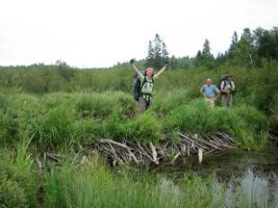
Workshop Description:
Moosewatch for Educators is a unique field experience in support of the ecological study of wolves and moose at Isle Royale National Park. Educators will receive the technical instruction needed to participate as a member of a backcountry research team. Although not as strenuous as “regular” Moosewatch Expeditions, participants will be operating in an off-trail wilderness setting involving travel by canoe and foot. You will learn field research methods, backcountry navigation, and backpacking/wilderness living skills. The workshop
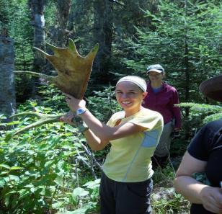
will integrate aspects of earth science, botany, general ecology, and the use of literature in teaching science. Participants will discuss development of lesson/unit plans for use at their local schools.

Goal and Objectives:
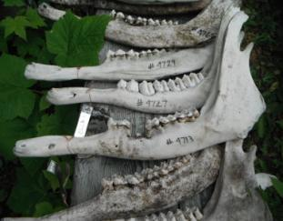
The general educational goal of this workshop is to enhance problem-solving and project-based learning skills of teachers and other educators by providing standards-based instruction within a real- world research setting. This goal will be fulfilled with curriculum incorporating more specific learning objectives and applicable activities related to:
- Field research methods to generate measurable scientific data;
- Field navigation techniques using GPS and compass;
- Wilderness living and travel techniques in a remote, backcountry environment;
- Experiential learning instructional strategies for elementary and secondary students; and
- Next Generation Science Standards.

Schedule of Activities: The field component of the workshop will be eight days in length. Travel to Isle Royale will be aboard Isle Royale Queen IV from Copper Harbor, MI. Instructional and experiential learning activities will take place at several coastal and backcountry locations accessible from the Rock Harbor channel. Travel to camp sites will be by boat and canoe with hiking excursions made from base camps. Instruction in field research methods, backcountry navigation, general ecology, and wilderness living skills are blended into daily activities. Participants will engage in reflective group discussions and share ideas for incorporating what has been learned into classroom instruction.
Cost: $1,200 resident/non-resident per participant – this covers 45 SCECH hours (continuing education approved by the State of Michigan for Michigan teachers), transportation from Copper Harbor to Isle Royale, water taxi and canoes, and an experienced IRI instructor-guide. Participants need to provide basic backpacking equipment and food. For more details, contact Karen Bacula - kbacula@mtu.edu
Limited to 5 educators. Apply early!
APPLICATION FORM: Moosewatch For Educators at Isle Royale

Please type or print in ink clearly. Duplicate as needed.

Name First Middle Last

Home address Street City State ZIP

Date of birth Home email

Home phone Work phone

Work fax Work email

School name

School address Street City State ZIP

Current subject areas taught

Grades taught

School district

I agree to all of the following in order to participate in a summer 2023 field session:
- Read and respond to all preparatory materials and communications prior to the workshop.
- Consent to the release of my name, address, and email address to other participants.
- Fully participate in each day of the field session.
- Meet the requirements of the syllabus for the workshop.
- Consent to the release of my photograph for publications.

Signature Date

Return the completed application form & questionnaire (attached) by MARCH 31, 2023, to:
Karen Bacula
Director, MTU Isle Royale Institute
Email: kbacula@mtu.edu
NOTE: Applicants will be notified of their acceptance to the workshop beginning April 1, 2023.
Upon acceptance to the workshop, participants will be provided a Moosewatch health form and session details. A $150 deposit is due by April 14, 2023, by check or money order made out to Michigan Technological University. Full payment is due at least one month before your session.

